Tenth Anniversary

Spring Student Conference
---------------------

“Where Your Deepest Gladness

and the World’s Deep Hunger Meet”

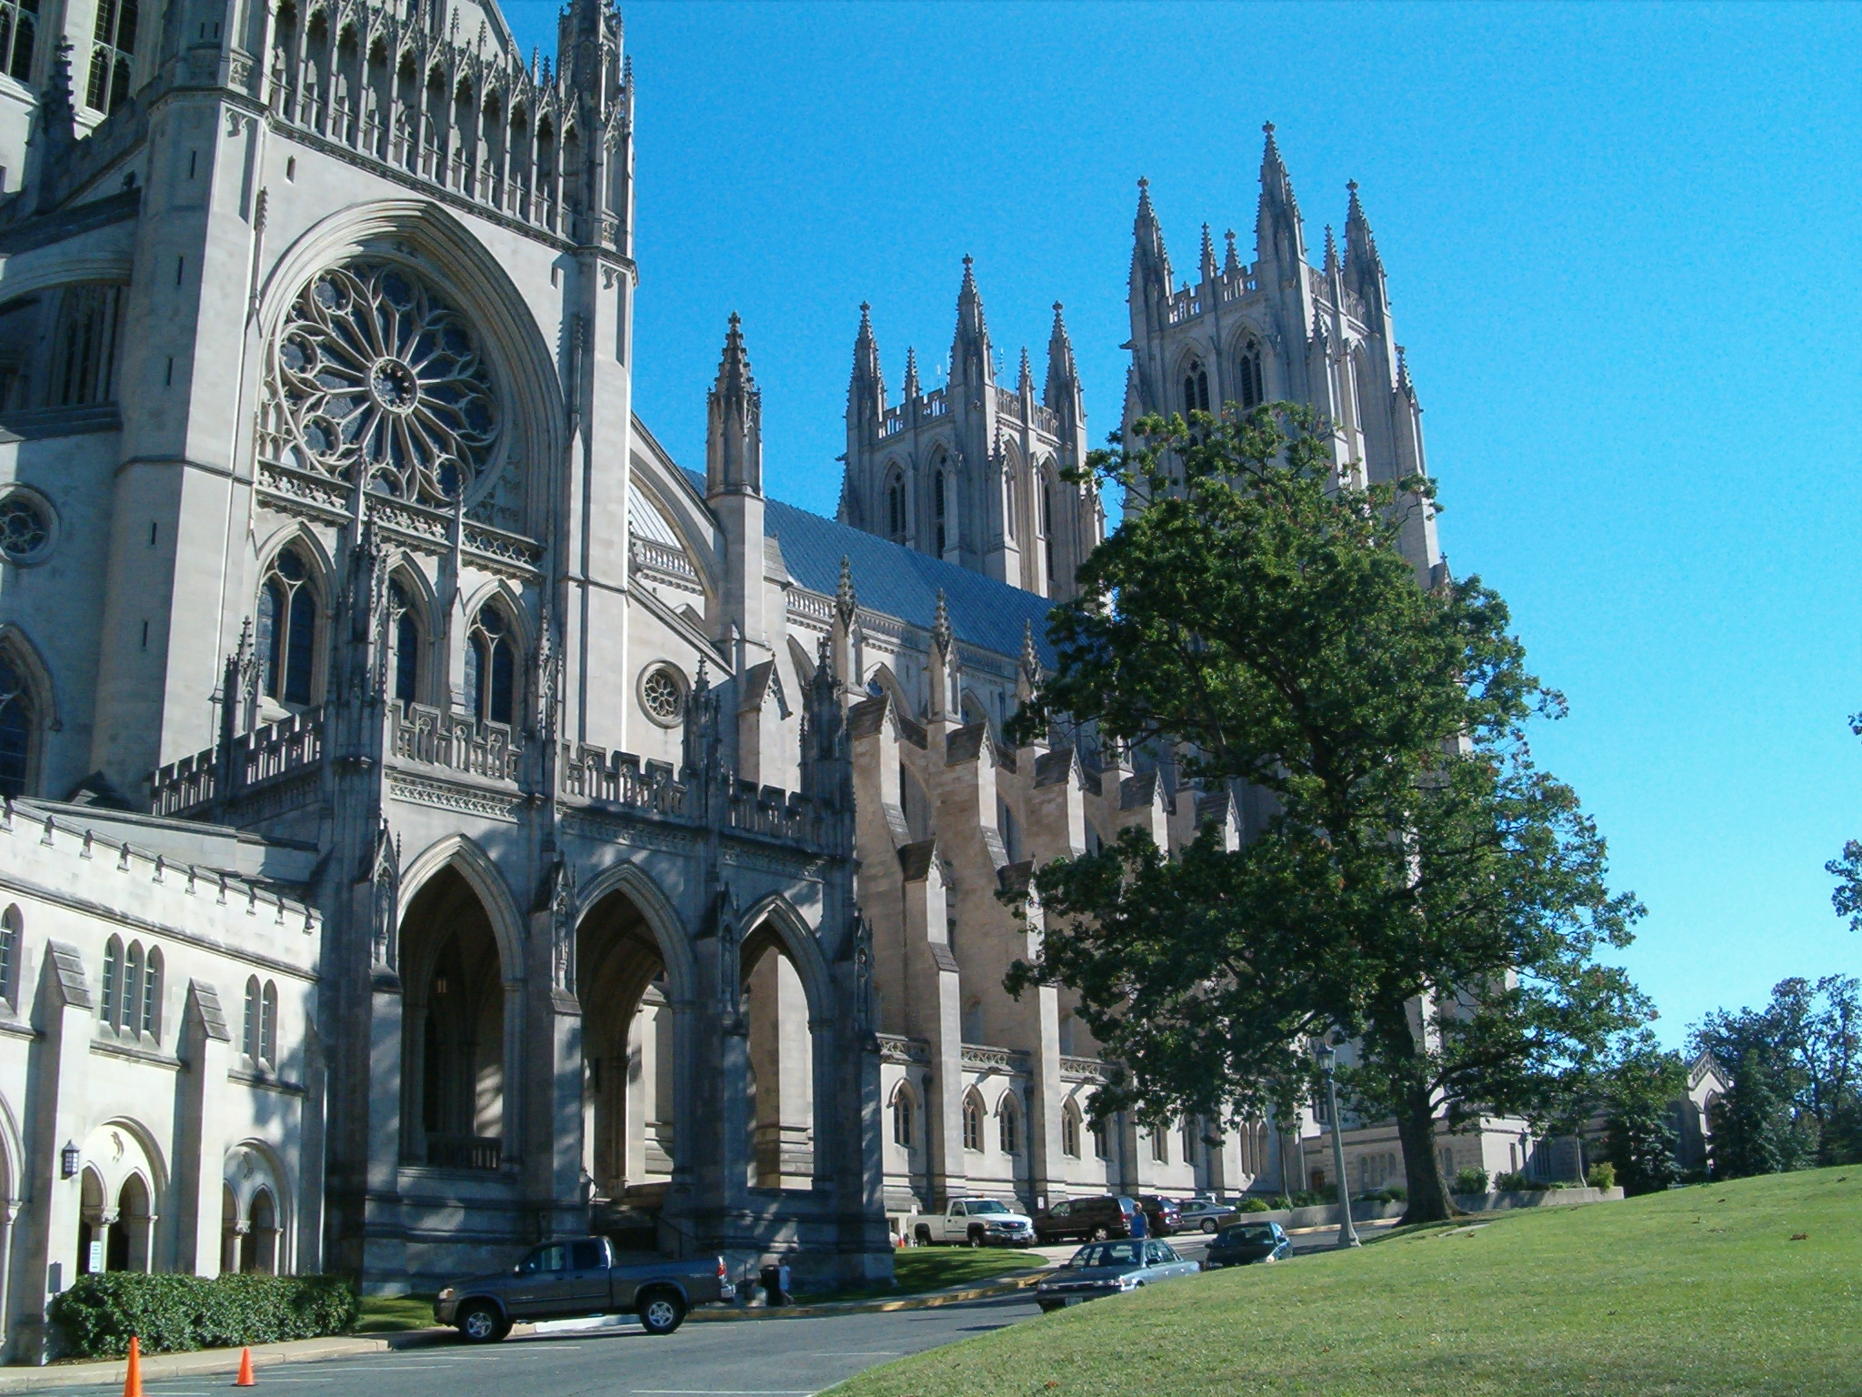
Reflections on Faith, Vocation,

& Culture



Sponsored by the Paideia College Society & The University Honors Program


Dallas

Baptist

University

February 23-24, 2007

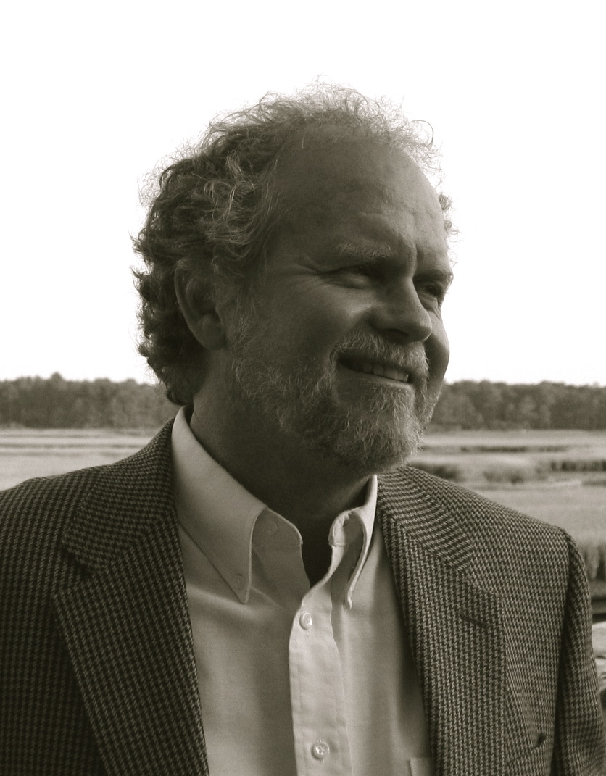
Keynote Speaker:
- Dr. Steve Garber

Steven Garber has a classroom among many people in many places. Known as “a public teacher,” at the heart of his own calling is the longing that people understand the integral character of faith, vocation, and culture. He directs The Washington Institute (http://www.washingtoninst.org/), which has as its core conviction that the church and society are renewed as a richer, truer vision of calling is taught and practiced. Steve is mentor to the bands “Jars of Clay” and “The Fray.” He is also the author of The Fabric of Faithfulness: Weaving Together Belief and Behavior (IVP 1996). As a Senior Fellow for the C.S. Lewis Institute, he is a contributor to the volumes, Faith Goes to Work: Reflections From the Marketplace and Get Up Off Your Knees: Preaching the U2 Catalog.. He also contributed to the Mars Hill Audio journal report, Tacit Knowing, Truthful Knowing: The Life and Work of Michael Polanyi. A native of the great valleys of Colorado and California, he is married to Meg and with their children, lives in Virginia where they are members of The Falls Church.

Dr. Garber’s Keynote Lecture Schedule:
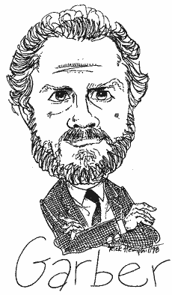
- Friday, February 23, Collins Learning Center @ 12 Noon: “A Vision of Faith: Belief and Behavior Twined Together”

- Saturday, February 24, Rogers BSM Room @ 11: 00 am: “A Vision of Vocation: Tearing a Corner Off of the Darkness”

- Saturday, February 24, International Student Building @ 7: 30 pm: “A Vision of Culture: Knowing and Loving the World at the Very Same Time”

“Walker Percy’s warning about the modern person’s “getting all A’s but flunking life” is a possibility lurking around the corner of everyone’s life. The vocation of teacher requires one to nurture cares and commitments [in students] which can be and should be sustained, ones that will last for life because they are worthy of a life.”

— Steven Garber, The Fabric of Faithfulness, p. 43.

|Special Musical Guest

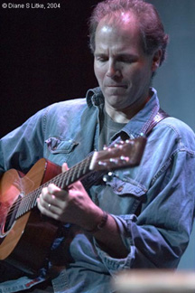
- Brooks Williams

Brooks is a stunning guitarist whose blues-soaked, rhythmic, and soulful music defies categorization. After fifteen solo recordings and nearly two decades of touring the world, he is one of the most well-respected players on the circuit. His musical vision spans continents and genres—blues, jazz, slide, fingerstyle—where creative chords, walking bass lines, and fiery riffs abound. Dirty Linen magazine calls Brooks Williams one of "America's musical treasures."

In Concert, Friday, February 23, Rogers BSM Room @ 7: 00 pm
FREE!

"How soulful a solo guitarist can be when he has talent, taste and astonishing technique."
(Blues Review)
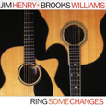
"Williams plays with the precision of a classically trained musician
and the soul of a barroom brawler."
(The Enterprise)

"His guitar sounds glorious and full-bodied. What IS that thing?"
(Guitar Player)

"Dazzling guitarwork!"
(Acoustic Guitar)

"Deft, tasteful guitar chops."
(Rolling Stone)

“He possesses a melodic virtuosity on the guitar that runs like liquid from his fingers and blows the socks off any other player you could name."
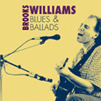
(The Irish News)

"A fret monster who has to be seen to be believed!"
(San Antonio Light)

"Brooks Williams is probably the best guitar player you'll see grace a stage. lWhether it's fancy flatpicking, delicate fingerpicking, rootsy blues or workmanlike acoustic rock, Williams delivers the goods."
(The Valley Advocate)

"If Williams' guitar picking gets any sharper, we'll have to create new adjectives."
(The Boston Globe)

“Stop, look, and above all listen!"
(Village Voice)

Conference Program:

Friday, February 23, 2007

--------------------

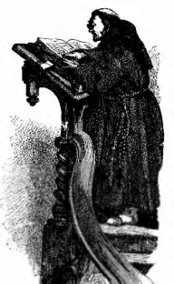
First Keynote Address:

Steve Garber Dr.Steven Garber

“A Vision of Faith: Belief and Behavior Twined Together”

12 noon, Friday Symposium, Collins Learning Center 316



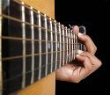
Brooks Williams Brooks Williams
In Concert
7: 00 pm, BSM Room, Refreshments, All Free!
 

Saturday, February 24, 2007



Location: International Student Center, Dallas Baptist University
Conference Registration and Continental Breakfast: 8: 15 am

Paper Presentations:

9: 00 - 9: 30 am:

- Joel Patrick: "Language and Meaning"
Room 109 A

- Jeremy Jordan: "Scientology: Cult and Consequences"
Room 109 B

- Holly Williams: "A Vision of Pain and Suffering in Julian of Norwich"
Room 110

- Hannah Harper and Brad Ledbetter: "Toddler to Top Dog: A Study in Organizational Behavior"
Room 111A

- Joe Justiss: "An Apology for Presuppositional Apologetics"
Room 111B

- S. Kyle Davis: Courageous vs. Moral Kingship in ‘The Passion of St. Edmund’”
Room 112

9: 35 – 10: 55 am

- David Miller: "Lesslie Newbigin on Evangelism and the Reign of God"
Room 109 A

- Lance Lormand: "The Scandal of Grace"
Room 109 B

- Ryan Swindle: "Knowing is Half the Battle: The Tragic Twist in C. S. Lewis’s Poem Lancelot – A Poem Worth Reading!"
Room 110

- Lance Higginbothom: "Cleansing Yahweh’s Temple: Exile in the Old Testament"
Room 111 A

- Kevin Neece: "The Good Fight: Faith and Vocation in Rocky Balboa"
Room 111B

- George Billingsley, “Puritanical Ideas in the Postmodern World: Their Relevance for Today”
Room 112

- Brandon Wike: “Jurisprudence- How Postmodernism has Impacted our Philosophical Concept of Law” –International Student Building Atrium area

10: 10 – 10: 40 am

- Daniel Haynes: "The Grounding of the Metaphysics of Ethics: Radical Orthodoxy and the Eastern Theology of Theosis"
Room 109 A

- Robby Pierce: "The Springs That Set Men Agoing: Reflections on Jonathan Edwards’ Treatise on the Religious Affections"
Room 109 B

- Hannah Briscoe: "From Feudalism to Freedom: The Rise of the Lombard Communes"
Room 110

- Joel Davis: "The Fresh Water Stream: A Biblical Understanding of Christian Speech"
Room 111 A

- Josh Stevens: "Augustine on Education"
Room 111B

- DeAnn Barta, “Teaching Objective Truth to a Pluralistic Age”
Room 112
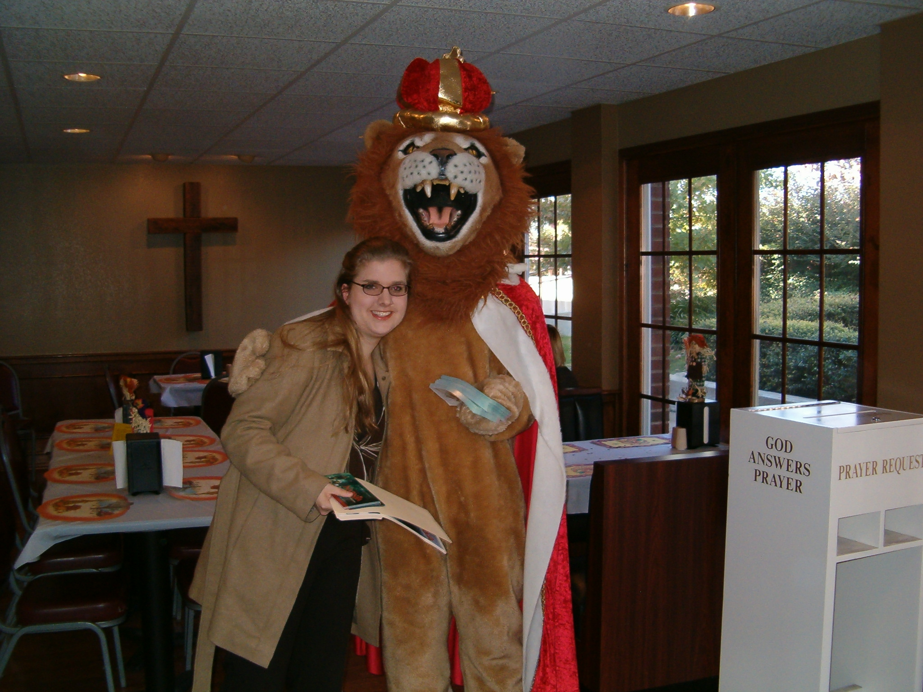

Morning Liturgy. 2nd Keynote with Dr. Garber. Lunch.

Baptist Student Ministry Room


Leigh Hickman and ‘Aslan’ (aka Chris Vitatoe)

11: 00 – 11: 15 am Liturgy Dr. Philip Mitchell, presiding

“With His help, I shall love Him the more ardently
the more I advance in learning.”

— Adeodatus (St. Augustine’s son)

11: 15 - 12: 30 pm Keynote Lecture Dr. Steve Garber

“A Vision of Vocation: Tearing a Corner Off of the Darkness”

12: 30 – 1: 30 pm Pizza Lunch Baptist Student Ministry Room
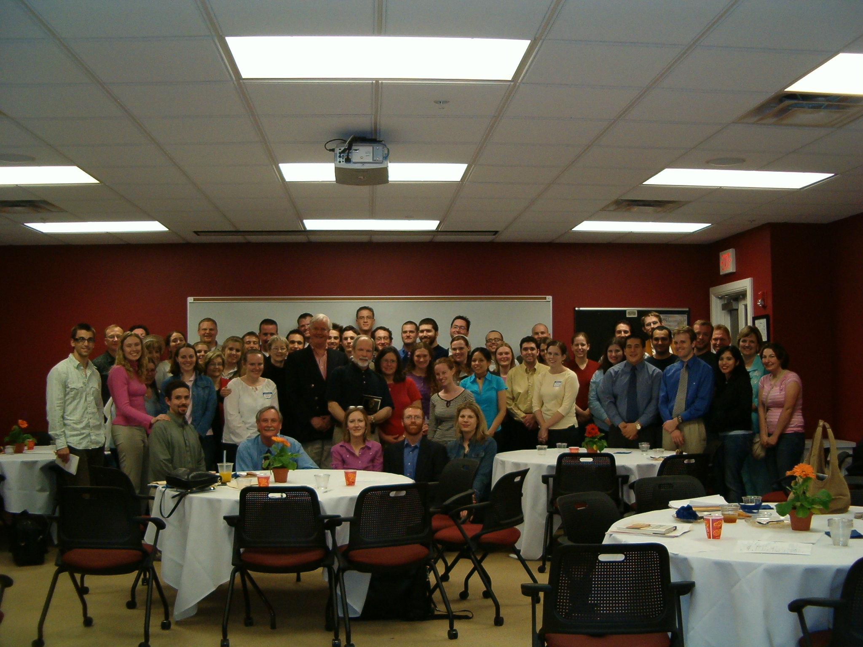
Paideia Conference Group Pic with Os Guinness, 2005

More Paper Presentations:

1: 45- 2: 15 pm

- Russell Hemati: "Augustine and Theological Determinism"
Room 109 A

- Blake Carlisle: "The Christian Unmoved Mover: Thomas’s First Argument from Motion – Analysis and Evaluation"
Room 109 B

- Jonathan Perdue: "Roe v. Wade: The Demoralization of Humanity"
Room 110

- Grant Daves: "The Pew/Paideia College Society, The Garber Model, and Guinness’s ‘Third Mission to the West’"
Room 111 A

- Adam Crumpler: "Will the Real Jesus Please Stand Up: Comparing Mormon and Evangelical Views of Jesus "
Room 111 B

- Tim Davis: “More Than a Theory, Less Than a Fact: In Quest of Questions About Wisdom”
Room 112

2: 20 – 2: 50 pm

- Christi Hemati: "Church Militant vs. Church Triumphant: A Critique of Kierkegaard’s Dualism"
Room 109 A

- Kevin Neece: "Man and Monster: Identity, Destiny and Belonging in Guillermo del Toro’s Hellboy"
Room 109 B

- Leigh Hickman: "Richard the Third Proves a Woman: Shakespeare’s Demoniac Guidebook to Sex-Subordinating Girl Power and the Erotic Witch Syndrome"
Room 110

- Jessica Irvin: "Our Mutual Friend: Marriage and Money"
Room 111 A

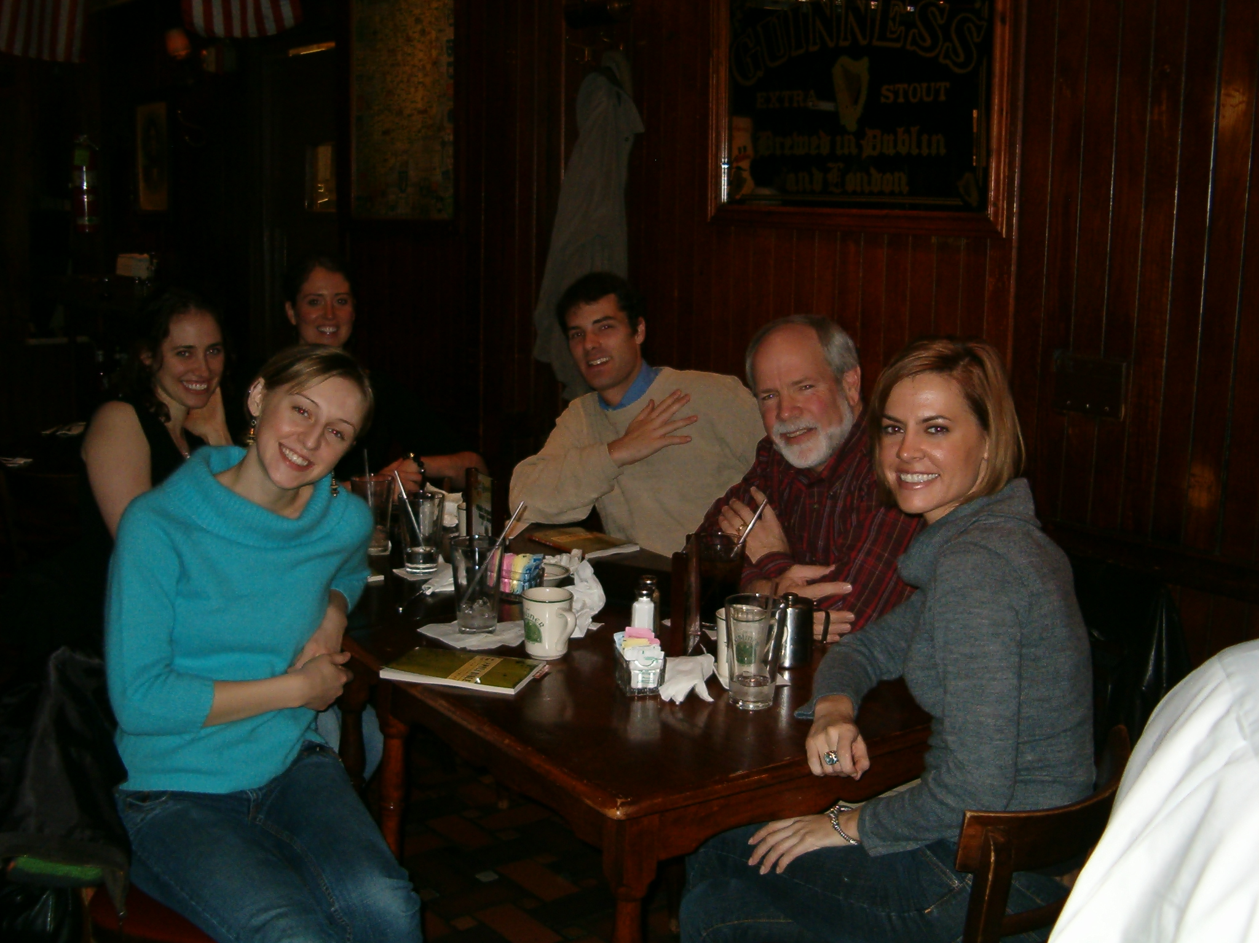
- Michael Sawilowsky: "Revelation 17-22 and Echoes of Eden: A Canonical Eye on Marriage”
Room 111 B

- Matthew Dingemans: “The Illusion of Objectivism: A Closer Look at Scientific Knowledge”
Room 112

2: 55 – 3: 25 pm
- Chris Vitatoe: "A Defense of Offense: Discerning Between Good Violence and Bad Violence"
Room 109 A Dr. Naugle with Pew/Paideia alums in Wash, D. C.

- Rachel McCabe: "The Meaning of Justice: Similarities and Shifts Through Time"
Room 109 B

- Artyom Tonoyan: "Do You Still Love Ataturk? Resurgent Islam in Turkey and Turkey’s Prospects of Joining the European Union"
Room 110

- Taryn Whittington: "Nietzsche and Mrs. Moore in E. M. Foster’s A Passage to India: The Dilemmas of Modernity"
Room 111 A

- Lauren Hickman: "Original Creation and the Call to Sub-Create in Tolkien’s Fiction: Humble Adornments and Mechanistic Makings as Brought into Being by Flame and Fire"
Room 111 B

- Natalie Stilwell: “Evangelical is Not Enough: My Journey to Rome” – Room 112

3: 30 - 4: 00 pm

- Nathan Bechtold: "Aletheia: Jesus, Greek Lexicons and Heidegger on Knowing the Truth"
Room 109 A

- Benny Barrett: "To Mend our Muddled Babel: Communicating the Word Through Words without Reason
Room 109 B

- Mark Boone: There is No Perhaps: Mind Games, Philosophy and Spy Fiction”
Room 110

- Alisha Barker: "But for to Beare us Felyshyp": The Deconstruction and Reconstruction of
Fellowship in Malory's Morte D'arthur
Room 111 A

- Theophan Alvarez: “With ‘Numeracy’ and Justice for All: Mathematics Instruction for Limited English Speaking Students”
Room 118

- Leticia Reyes: "Mexican Protestantism in the Nineteenth Century: A Brief Overview."
Room 112

--------------------------- Afternoon Break -------------------------

4: 00 pm until 6: 00 pm

Kuyper is ready to play

Concluding Mexican
Buffet Banquet

6: 00 pm - International Student Building
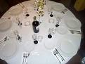
3rd Keynote with Dr. Steve Garber
7: 30 pm International Student Building

“A Vision of Culture:
Knowing and Loving the World at the Very Same Time”

------------------------------------------------------------------------
"... I'm a musician. I write songs. I just hope when the day is done I've been able to tear a little corner off of the darkness...." Bono, U2
------------------------------------------------------------------------

Don’t Miss These Other Upcoming Events

Remaining Friday Symposium Lectures

- March 2 — Prof. Ross O’Brien — “Bad to Good: On Science and the Search for Truth in Business Ethics”

- March 9 — Robert Whitfield — “‘A National House of Prayer for All People’ — A Historical, Architectural, Religious and Cultural Look at the National Cathedral in Washington, D.C.”

- March 23 — Ken Myers — “Why There Really IS a War between Science and Christianity: C. S. Lewis’s Vision of a “Repentant Science”

- March 30 — Dawn Waters Baker- “Communicating God in Art”

- April 13 — Al Haley (This lecture is a part of the new DBU literary festival) “Masters of Metaphor: Faith and Creative Writing”

- April 20 — Dr. John Jaeger — "Reviving Interest in Books and Reading in an Age of Blogging and MySpace"

- April 27 — Prof. Todd Von Helms — “‘Sinners in the Hand of an Angry God’ Revisited — A Dramatic Presentation: Jonathan Edwards and His In/Famous Sermon in Context”

In theaters February 23!
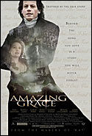

http://movies.aol.com/movie/amazing-grace-2007/27330/main

“Is it not the great end of religion, and, in particular, the glory of Christianity, to extinguish the malignant passions; to curb the violence, to control the appetites, and to smooth the asperities of man; to make us compassionate and kind, and forgiving one to another; to make us good husbands, good fathers, good friends; and to render us active and useful in the discharge of the relative social and civil duties?” - William Wilberforce

“If to be feelingly alive to the sufferings of my fellow-creatures is to be a fanatic, I am one of the most incurable fanatics ever permitted to be at large.” - William Wilberforce

“So enormous, so dreadful, so irremediable did the Trade's wickedness appear that my own mind was completely made up for Abolition. Let the consequences be what they would, I from this time determined that I would never rest until I had effected its abolition.”
- William Wilberforce

“God Almighty has set before me two great objects, the suppression of the slave trade and the reformation of manners.” - William Wilberforce


3.25.07 Dallas, TX Gypsy Tea Room

You buy your ticket; I’ll buy your dinner – Dr. Naugle 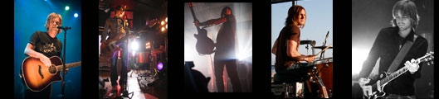
--------------------------------------------------------------------------------------------------------

"...So at the end of our time as a band perhaps we will have only one song to sing -- just one very long, rambling, eclectic song that touches on life, death, pain, sex, anger, joy, peace, politics, God and the other elements of a searching soul in the twenty first century.
Maybe at the end of my life I will sing only one song, a song that has been refined and purified. A lonely group of notes that will be a sweet, sweet sound for an audience of one..." - Jon Foreman, Switchfoot


PAIDEIA COLLEGE SOCIETY
END-OF-SEMESTER BBQ!
MAY 4, 2007 AT 6: 00 PM
DR NAUGLE’S PLACE — 1110 BIG STONE GAP
DUNCANVILLE, TEXAS

